SUMMATIVE ASSESSMENT
FULL NAME & SURNAME

ID NUMBER:

NAME OF ASSESSOR

DATE OF ASSESSMENT

VENUE

 |  | COURTNEY ROSENBERG
 |  | 2ND FLOOR, 679 PAUL KRUGER STREET LES MARAIS, 0084
ACHIEVED |  |  | NOT ACHIEVED
KNOWLEDGE
SKILLS

Signature of learner Signature of Assessor

ASSESSMENT PACK
___________________________________________________________________ Please complete the following sections (A and B) before commencing with this assessment. The moderator of this assessment will complete section C.
Section A Learner Information
Name:
Surname:
Date:
Contact telephone no:
Learnership agreement no:
Company: |  |  |  |  |  |  |  |  |  |  |  |  |  |  |  |  | Site:
ID
 |  |  |  | Section B Assessor Information
Name: |  |  |  |  |  |  |  |  |  |  |  |  |  |  |  |  |  | COURTNEY
Surname: |  |  |  |  |  |  |  |  |  |  |  |  |  |  |  |  |  | ROSENBERG
Date: |  |  |  |  |  |  |  |  |  |  |  |  |  |  |  |  |  | / / 20
Contact telephone |  |  |  | no: |  |  |  |  |  |  |  |  |  |  |  |  |  | 087 655 1907
Assessor no: |  |  |  |  |  |  |  |  |  |  |  |  |  |  |  |  |  | 19A78062010
Provider no: |  |  |  | 07-SAS/SDP260122-431 |  |  |  |  |  |  |  |  |  |  |  |  |  | Site: PRETORIA
ID | 7 | 3 |  | 0 |  | 3 |  | 0 |  | 8 |  |  |  | 5 |  | 1 |  |  |  | 4 |  | 3 |  |  |  | 0 |  | 8 |  | 0
 |  |  |  | Section C Moderator Information
Name: |  |  |  |  |  |  |  |  |  |  |  |  |  |  |  |  | OLIVE
Surname: |  |  |  |  |  |  |  |  |  |  |  |  |  |  |  |  | ROSENBERG
Date: |  |  |  |  |  |  |  |  |  |  |  |  |  |  |  |  | / / 20
Contact telephone |  |  |  | no: |  |  |  |  |  |  |  |  |  |  |  |  | 087 655 1907
Moderator no: |  |  |  |  |  |  |  |  |  |  |  |  |  |  |  |  | 19M78101776
Company: |  |  |  | 07-SAS/SDP260122-431 |  |  |  |  |  |  |  |  |  |  |  |  | Site: PRETORIA
ID | 7 |  | 4 | 1 | 2 |  | 0 |  | 8 |  |  |  | 0 |  | 1 |  |  |  | 2 |  | 4 |  |  |  | 0 |  | 8 |  | 4
Results:



:Assessors Guide

1. Instructions to Assessor

Introduction:

This assessment guide has been designed as a generic assessment guide and is intended for use by the accredited Security Industry Training Providers.

Purpose of the assessment

The purpose of summative assessment against this unit standard is to:

♦ Award credits to the NQF to learners who are able to Handle and defuse security related conflict

Learning assumptions

The following knowledge, skills, attitude and/or equivalent:

♦ A knowledge, comprehension and application of language at NQF 02.

Assessment methods

The following assessment methods will be used for the summative assessments:

♦ Written and/or/verbal questioning
♦ Product sample and on site assessment

2. Assessment Process

General

♦ Use the assessment guide and your latest company policies and standard operating procedures to assess the evidence received from the learner.
♦ Use the section: Addition Comments/Questions to note down any further comments or questions on the evidence assessed.
♦ Use the model answers as a guideline to assess the learner’s answers to the assessment questionnaire.
♦ The learner can complete the assessment questionnaire orally. In this case, agree a date, time and venue.
♦ Provide the learner with a feedback within 10 working days of receiving the evidence.

Step 1 - Planning for the Assessment

Review this assessment guide to:

♦ Ensure that you understand all the requirements of the assessment in terms of evidence required to prove competence.
♦ Identify and prepare the learner for the assessment by:

⇒ Completing the Assessment Plan with the learner to discuss and agree the details regarding the assessment.
⇒ Completing the Assessment Preparation Checklist and getting the learner to sign.

♦ Ensure that you have familiarized yourself with the following:

⇒ Courts of law in South Africa ⇒ The preparation of a witness
⇒ The process of giving evidence
⇒ The court process
⇒ The process of providing feedback

Step 2: Complete the Assessment

♦ Collect the evidence in accordance with the methods and evidence requirements specified.
♦ Mark each question as correct or incorrect in the “Office Use” column.
♦ Record the evidence on the assessment guide and indicate “Competent”, “Not Yet Competent” or “Not Assessed” for each assessment criterion. Note down any comments at the back of the assessment guide.
♦ Ask the learner additional questions, if necessary, to clarify points. Record these on the guide.
♦ All questions must be complete as per the criteria specified. ♦ Answers provided must be similar to the model answers.

Step 3 - After the Assessment

♦ Prepare the feedback by writing comprehensive, developmental feedback after each section on the Assignment Sheets. In addition to this, you are required to write a summary overall feedback on the Assessment Guide.
♦ Provide the feedback to the learner in a safe, undisturbed in nature.
♦ Ensure that your feedback is developmental and supportive in nature.
♦ Advise the learner on what action to follow in the event of a “Not Yet Competent” rating.
♦ Advise the learner on what action to take where he/she feels the need to appeal against your decision.
♦ Allow the learner time to provide you with feedback relevant to the process.
♦ Record the learner’s feedback in the guide and ensure that it is given to the person responsible for the quality assurance of assessment tools.
♦ Ensure that the learner co-signs the assessment guide to indicate agreement with the feedback.
3. Assessment documentation required:

Step 1: Planning for the Assessment

♦ Assessment Plan
♦ Assessment Preparation Checklist
♦ Assessment Policy (including Appeals)
♦ Evidence Matrix
♦ Assessment Instruments

Step 2: Conducting the Assessment

♦ Assessor Guide
♦ Learner’s workbook
♦ Summative assessment pack

Step 3: After the Assessment

♦ Assessment Comments
♦ Feedback Report

4. Specific Instructions

Please note that Part 3 Assessment Instruments are not included in this guide and are to be included by the assessor on an individual basis.

The actual summative assessments need to be completed and signed off by both learner and assessor. The assessor will take control of the completed assessment instruments and will file them under the tab for Assessment Evidence.

The completed assessment pack will be kept in safekeeping at the training provider for three months after endorsement by SASSETA and will then be returned to the learner.

Guidelines where an appeal is lodged

The normal appeal procedure prescribed by SASSETA and described by the provider’s Quality Management System will be followed.



:Assessment Planning

ASSESSMENT PLAN
ASSESSMENT DETAILS
Date of Assessment |  |  |  | Option 1 |  | Option 2 |  | Option 3 | Option 4
TIME OF ASSESSMENT
Start: |  |  |  |  |  | End:
VENUE |  |  |  |  |  | Contact person
LANGUAGE MEDIUM
METHOD OF ASSESSMENT (please tick off the one to be used)
OBSERVATION |  |  | ORAL |  |  |  | WRITTEN
Simulation |  |  | Knowledge test |  |  |  | Knowledge  test
Product |  |  | Interview
_______________________________________________________________________
_______________________________________________________________________
_______________________________________________________________________
_______________________________________________________________________
_______________________________________________________________________

PRE-ASSESSMENT MEETING CHECKLIST
ACTION | YES/NO | COMMENTS
Set learner at ease; be friendly, polite and professional.
Explain to the learner and agree on the following issues.

- The unit standard that will be assessed
- Date, time, venue and process to be followed during the assessment.
- Summative assessment tools to be used for the assessment.
- The assessment plan
- Purpose of assessment
Explain to the learner and agree on the role of all involved during the assessment process.
Identify possible barriers and or disabilities of the learner.
Explain the meaning and application of RPL.
Explain, discuss and provide one complete set of the Appeals process documentation.
Explain to the learner when final results will be available and how feedback will be provided.
Discuss previous assessment results if applicable.
I, ______________________________ (initials and surname of learner), DECLARE THE FOLLOWING:

A copy of the unit standard(s) involved has been given to me prior to this meeting. I know I will be assessed against the criteria, which have been set to the applicable unit standards. The criteria have been discussed with me, and the procedures and purpose of the assessment has been clearly explained to me.

I am well aware of the venue, date and time that I will be assessed. I consider the period of time given to me to prepare myself for the assessment to be fair.

I understand clearly that I have the right to appeal against any decision made by the assessor during the assessment of the evidence provided by me, and that I have free access to the appeals procedures attached to this assessment pack. I understand that I have the right to be accompanied by another person during all procedures, and that I have free access to the Training Division of SBV’S Health and Safety Procedures- filed at the offices.

____________________ ____________________
Signature of learner Date


:Assessment Evidence

Assessment Instruments


The assessment instruments included in this assessment pack are all summative assessment instruments and are to be read in conjunction with the formative assessment instruments contained in the learner workbook. Both formative (workbook) and summative assessments are to be retained as part of the learner’s portfolio of evidence.
A number of the assessment instruments contained in this assessment are workplace knowledge based questions.

This means that you will arrange with the learner, a time that is suitable, during which the learner will complete each questions.

QUESTION 1: Identify the correct court procedures while a typical court procedure will be simulated by various role players. Use the checklist below placing the procedures in the correct order.
CHECKLIST:

Place the following processes in the correct order according to court proceedings in the table. Indicate the sequence by numbering them from 1 to 11.
NO. |  | PROCESS
1. |  | Address by Public Prosecutor
2. |  | Application for discharge
3. |  | Arguments of the Public Prosecutor and defense
4. |  | Cross-examination
5. |  | Evidence for the defense
6. |  | Evidence for the State
7. |  | Examination of witnesses by court
8. |  | Examination-in-chief
9. |  | Plea
10. |  | Re-examination
11. |  | Verdict
INSTRUCTION
1. Transfer the correct sequence to the blank table below in the “Process” column.
2. Match the process with the correct person that would be involved in that process from the following list:

⇒ Accused
⇒ Court Orderly
⇒ Court recording operator
⇒ Interpreter
⇒ Legal representative(s)
⇒ Prosecutor
⇒ Presiding Officer as Judge
⇒ Presiding Officer as Magistrate
⇒ Witnesses
3. Match both the proceeding, and the person, to the documentation listed below.

⇒ Charge sheet or indictment
⇒ Report
⇒ Statement ⇒ Subpoena
⇒ Summons
NO. | PROCESS |  |  |  | PERSON/S |  | DOCUMENTS
1.
2.
3.
4.
5.
6.
7.
8.
9.
10.
11.
RESULT OF CASE |  |  | Achieved | Not achieved |  | Not assessed
QUESTION 1 = 11
QUESTION 2 = 11
QUESTION 3 = 11
TOTAL. Possible 33
Minimum requirement=27/33
Comments in support of decision
_______________________________________________________________________
_______________________________________________________________________
_______________________________________________________________________
_______________________________________________________________________
_______________________________________________________________________
_______________________________________________________________________

QUESTION 2: ROLE PLAY
The learner needs to take note that he/she will be required to take part in a role play. The purpose of this exercise is to determine if the learner understands to the court procedure.

Instructions: You must make your own assumptions regarding the missing details.

1. The learner needs to act as a witness during a simulated trial. The preparation of being a witness is based on the case scenario below.

CASE SCENARIO

Real estate tycoon and widow of the millionaire John Smith, Sarah Louise FarmingtonSmith, has a passion for selling commercial and residential real estate which is only out shadowed by the love she has for her constant companion, Churchill a registered Cavalier King Charles Spaniel.

Churchill lives in the lap of luxury with Ms. Farmington-Smith and her various servants in a 3 story mansion in the city of Bloomingthorp. On the night of July 15, 2005, after a festive dinner party given by Ms. Farmington-Smith to celebrate her latest commission, it is discovered that Churchill is missing and a ransom note has been left in his place. A frantic search of the mansion has been conducted by Ms. Farmington-Smith, her housekeeper, Bernadette, her cook, Belize, and her chauffeur, François. It is also discovered that a basement window has been broken which is probably the means of entry and/or exit of the dognapper.

The police are called, and considering Ms. Farmington-Smith’s major contributions to the current political powers, her case is given the highest priority.

Captain Sam Bluffton, the head of detectives, is assigned the job of solving this crime.
Criminalists are called to the scene to collect the evidence. Detectives question everyone in the house and guests who attended the party at the house on the evening of July 15th.

The following is a list of the dinner party guests:

♦ Mr. Jules and Mr. Julius Poulet, identical twin antiques dealers from Louisiana who live with 12 cats.
♦ Mr. Bertran and Miss Bethany Beaufort, next-door neighbors from “old” money (brother and sister) who prize their pure-bred English saddle horses and regularly attend fox hunts.
♦ Mayor Chad and Mrs. Clarisse Chaucer, Mayor and First lady of Bloomingthorp, who are outdoor hunting enthusiasts.
♦ Mr. Theodore and Mrs. Theresa Plimpton, Ms. Farmington’s financial advisor and personal accountant, respectively; also, animal-haters.
♦ Skip and Skipper Savant, owners of the SSS railroad system and who both have severe animal allergies.
♦ Dr. Louis and Mrs. Annabelle Swarthington, local plastic surgeon and his “high society” wife, who have a matched pair of blue and white parakeets.
♦ Biff and Buffy Smith, nephew of John Smith and his wife – breeders of hunting dogs.

The other servant/employees on staff at the mansion are Charlie Porter (YOU THE LEARNER) , the gardener and Mike Buff, the pool guy.

As police detectives question everyone involved, they discover that EVERYONE except for Charlie Porter has a motive to do harm to Ms. Farmington-Smith….
It seems that all the employees are also disgruntled.

Motives abound but who took Churchill?????

A second note is sent to the local newspaper the next morning. It has been printed this time instead of being written by hand. It states that R23 Million should be dropped off at Wal-Mart at 12 noon on Saturday, behind the cases of Pepsi in the food section.

A phone call is received by Ms. Farmington-Smith directing her to drop off a briefcase with R50, 000,000 in it behind the local Humane Society, where she will find her beloved Churchill. When she tells the caller that she has already been directed to drop off money
(and substantially less money?!?) at Wal-Mart, the
“dognapper” tells her that an imposter is at work. To substantiate this, the caller tells her that Churchill’s favorite blanket was also taken during the dog napping.

Ms. Farmington-Smith, distraught but willing to do anything to get her beloved pet back, does as the caller orders. She promptly finds Churchill in the local shelter – dirty and fleainfested, but in good spirits. (Of course NO animals could be harmed in the telling of this story!!!)

The police later discovered that Charlie Porter have witnessed the complete crime. Charlie is questioned as a result of him being a key witness.
INSTRUCTION:

- Prepare yourself for giving evidence in a court by studying the case study.
- You can use imaginary detail during questioning. This detail must however be submitted to the assessor prior the role play. (Preparation time to give verbal evidence will be provided.)
untouched.
2 POINTS: Incomplete, did not address the elements.
0 POINTS: Nothing done, no evidence to assess.

♦ Accused
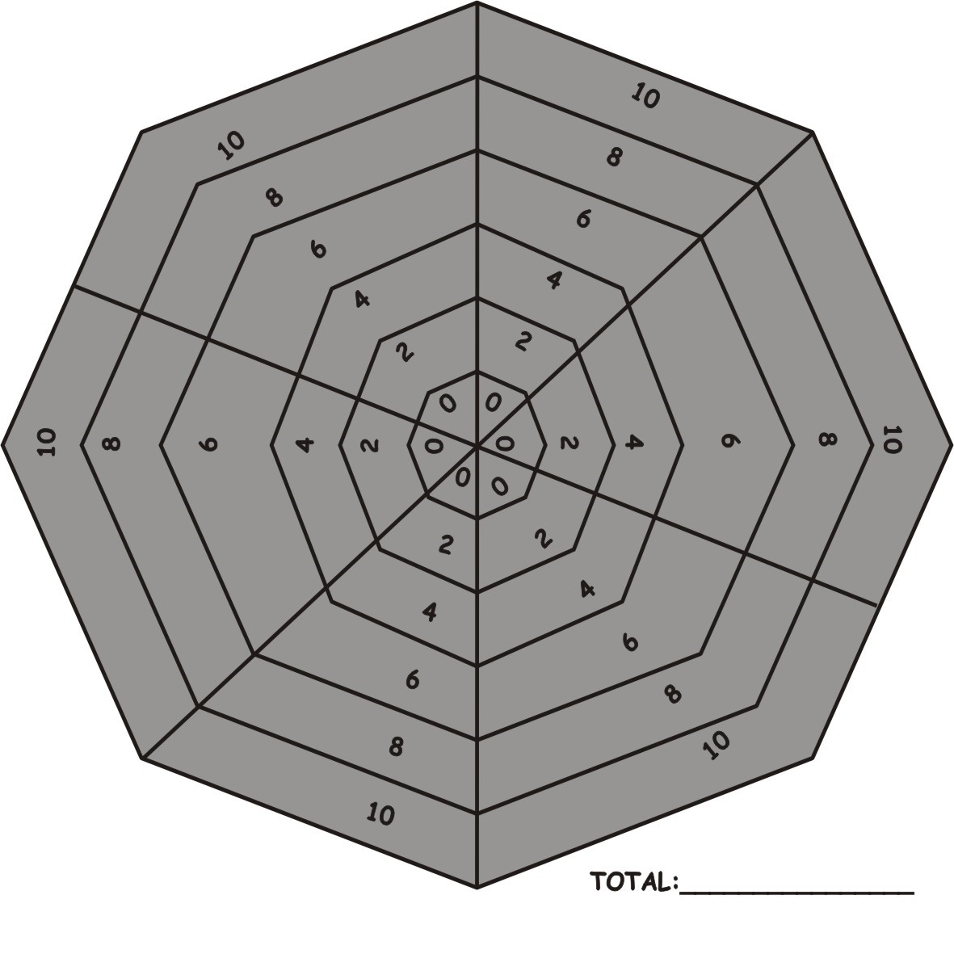

untouched.
2 POINTS: Incomplete, did not address the elements.
0 POINTS: Nothing done, no evidence to assess.

♦ Court orderly
untouched.
2 POINTS: Incomplete, did not address the elements.
0 POINTS: Nothing done, no evidence to assess.

♦ Court recording operator
untouched.
2 POINTS: Incomplete, did not address the elements.
0 POINTS: Nothing done, no evidence to assess.

♦ Interpreter
untouched.
2 POINTS: Incomplete, did not address the elements.
0 POINTS: Nothing done, no evidence to assess.

♦ Legal representative
untouched.
2 POINTS: Incomplete, did not address the elements.
0 POINTS: Nothing done, no evidence to assess.

♦ Prosecutor
untouched.
2 POINTS: Incomplete, did not address the elements.
0 POINTS: Nothing done, no evidence to assess.

♦ Presiding officer as judge
untouched.
2 POINTS: Incomplete, did not address the elements.
0 POINTS: Nothing done, no evidence to assess.

♦ Presiding officer as Magistrate
untouched.
2 POINTS: Incomplete, did not address the elements.
0 POINTS: Nothing done, no evidence to assess.

♦ Witness

RESULT OF CASE | Achieved | Not achieved | Not assessed
Accused: = 10
Court Orderly: = 10
Court recording operator = 10
Interpreter = 10
Legal representative (s) = 10
Prosecutor =10
Presiding Officer as Judge = 10
Presiding Officer as Magistrate = 10
Witnesses = 10
TOTAL. Possible 90
Minimum requirement=72/90
Comments in support of decision
_______________________________________________________________________
_______________________________________________________________________
_______________________________________________________________________
_______________________________________________________________________
_______________________________________________________________________
_______________________________________________________________________ QUESTION 3: Explain the legislative requirements for the presenting verbal evidence in court.
_______________________________________________________________________
_______________________________________________________________________
_______________________________________________________________________
_______________________________________________________________________
_______________________________________________________________________
_______________________________________________________________________
_______________________________________________________________________
_______________________________________________________________________
_______________________________________________________________________
_______________________________________________________________________
_______________________________________________________________________
Requirements achieved | YES |  | NO
Comments in support of decision
_______________________________________________________________________
_______________________________________________________________________
_______________________________________________________________________
_______________________________________________________________________
_______________________________________________________________________ QUESTION 4: Why should you give verbal evidence in a structured and logical sequence?
_______________________________________________________________________
_______________________________________________________________________
_______________________________________________________________________
_______________________________________________________________________
_______________________________________________________________________
_______________________________________________________________________
_______________________________________________________________________
_______________________________________________________________________
_______________________________________________________________________
_______________________________________________________________________
_______________________________________________________________________
Requirements achieved | YES |  | NO
Comments in support of decision
_______________________________________________________________________
_______________________________________________________________________
_______________________________________________________________________
_______________________________________________________________________
_______________________________________________________________________ QUESTION 5: Explain what is meant with the principle relating to the hearsay rule or hearsay evidence?
_______________________________________________________________________
_______________________________________________________________________
_______________________________________________________________________
_______________________________________________________________________
_______________________________________________________________________
_______________________________________________________________________
_______________________________________________________________________
_______________________________________________________________________
_______________________________________________________________________
_______________________________________________________________________
_______________________________________________________________________
Requirements achieved | YES |  | NO
Comments in support of decision
_______________________________________________________________________
_______________________________________________________________________
_______________________________________________________________________
_______________________________________________________________________
_______________________________________________________________________ QUESTION 6: Explain how to present and conduct yourself as a witness in a professional manner in court?
_______________________________________________________________________
_______________________________________________________________________
_______________________________________________________________________
_______________________________________________________________________
_______________________________________________________________________
_______________________________________________________________________
_______________________________________________________________________
_______________________________________________________________________
_______________________________________________________________________
_______________________________________________________________________
_______________________________________________________________________
Requirements achieved | YES |  | NO
Comments in support of decision
_______________________________________________________________________
_______________________________________________________________________
_______________________________________________________________________
_______________________________________________________________________
_______________________________________________________________________ QUESTION 7: List the officer’s duties as a witness prior to commencement of a court case.
_______________________________________________________________________
_______________________________________________________________________
_______________________________________________________________________
_______________________________________________________________________
_______________________________________________________________________
_______________________________________________________________________
_______________________________________________________________________
_______________________________________________________________________
_______________________________________________________________________
_______________________________________________________________________
_______________________________________________________________________
Requirements achieved | YES |  | NO
Comments in support of decision
_______________________________________________________________________
_______________________________________________________________________
_______________________________________________________________________
_______________________________________________________________________
_______________________________________________________________________

QUESTION 8: BEHAVIOURAL ASSESSMENT: Indicate whether the following behaviour would be acceptable when giving testimony in court, by completing “Yes” or No”
 | BEHAVIOUR |  |  |  |  | YES | NO
 | Address the court by speaking in the provided microphone.
 | Be too talkative.
 | Be calm and talk when questioned.
 | Chew chewing gum or eat anything while in the witness box.
 | Exaggerate your evidence.
 | Face the Presiding Officer and address or direct your answers to the Presiding Officer.
 | Listen carefully to the question.
 | Lounge (lean against/relax) in the witness box.
 | Make jokes and humour the court or try to be a joker.
 | Stand upright and ensure that your posture is professional.
 | Vary your tone of voice.
 | Wait in the witness box until you are requested to leave.
 | Wait until the question is asked and then answer.
 | TOTAL:
 | Requirements achieved | YES |  | NO
 | Comments in support of decision
_______________________________________________________________________
_______________________________________________________________________
_______________________________________________________________________
_______________________________________________________________________
_______________________________________________________________________
_______________________________________________________________________
_______________________________________________________________________

